**Number Sequence Tutorial**

Steps

1. Make Your Table
2. Make form and add table to its data source.
3. 3 make gird and add field into it.
4. First create a new **Extended Data Type (EDT)**. Open **AOT →Data Dictionary → Extended Data Types**
5. Right Click on **Extended Data Types** and create a new EDT **FahadNewCustomerTableEDT**of type **String**
6. 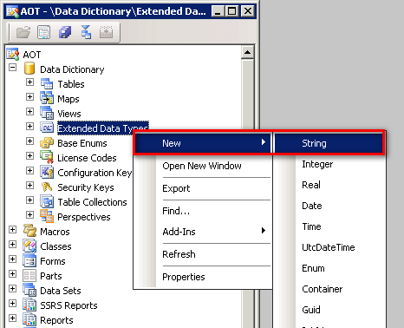
7. Set the properties as shown below
   1. 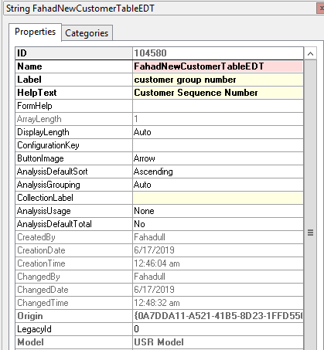
8. Make a new class FahadNewClassNumSeq
9. Now go to **AOT → Classes** and open the FahadNewClassNumSeq class by right clicking it and selecting **View Code**
   1. 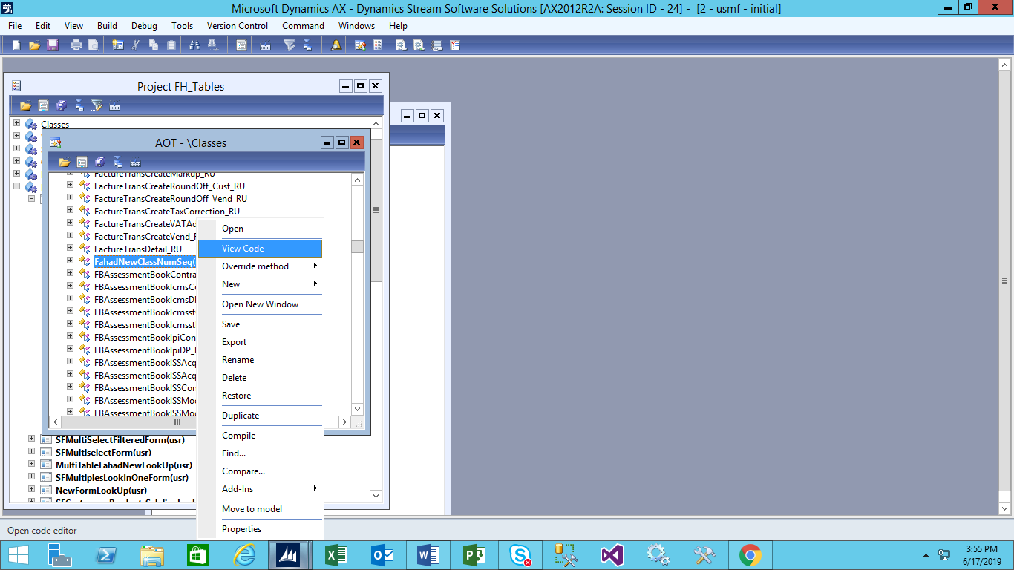

Make a class:

|  |
| --- |
| **class** FahadNewClassNumSeq **extends** NumberSeqApplicationModule  {  NumberSeqFormHandler numberSeqFormHandler;  } |

Make a new load module under this class and add the following code

|  |
| --- |
| * 1. **protectedvoid** loadModule()   2. {      1. NumberSeqDatatype datatype = NumberSeqDatatype::construct();      2. ;   3. datatype.parmDatatypeId(**extendedTypeNum**(FahadNewCustomerTableEDT));      1. datatype.parmReferenceHelp(**literalStr**("Unique number for customer group"));      2. datatype.parmWizardIsContinuous(**true**);      3. datatype.parmWizardIsManual(NoYes::No);      4. datatype.parmWizardIsChangeDownAllowed(NoYes::No);      5. datatype.parmWizardIsChangeUpAllowed(NoYes::No);      6. datatype.parmWizardHighest(**999999**);      7. datatype.parmSortField(**27**);      8. datatype.addParameterType(NumberSeqParameterType::DataArea, **true**, **false**);      9. this.create(datatype);  1. } |

1. Make a new Job and add the following code

|  |
| --- |
| * 1. **static void** FahadLoadNumSeqCustDemo(Args _args)   2. {   3. *//define the class variable*   4. FahadNewClassNumSeq FSeqMod = **new** FahadNewClassNumSeq();   5. *//load the number sequences that were not generated*   6. FSeqMod.load();   7. } |

1. Now, go to **Organization administration → Common → Number sequences → Number sequences**
   1. 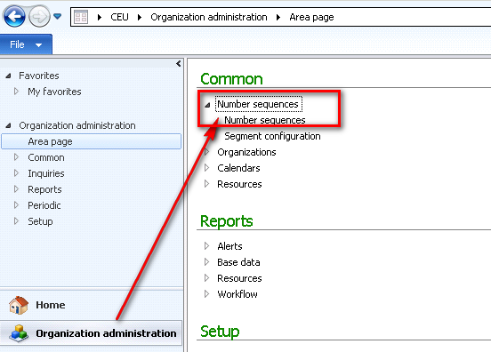
2. Click on **Generate** button in the **New** button group
   1. 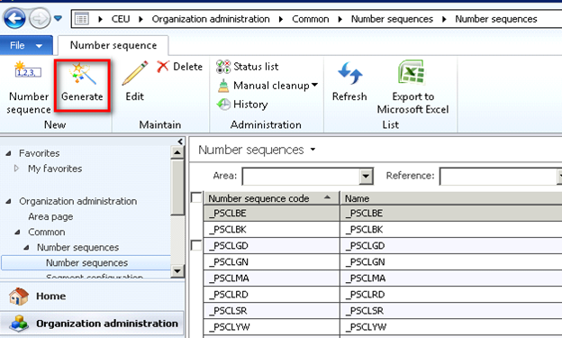
3. In the Setup number sequences wizard, Press **Next**
   1. 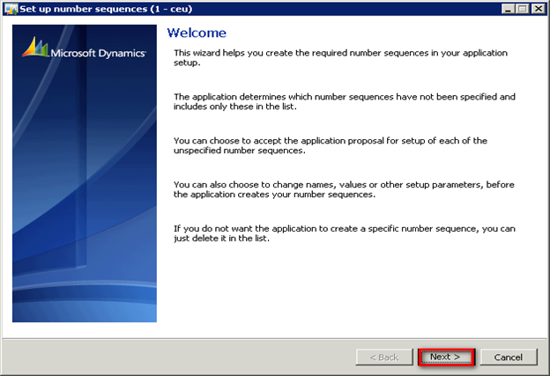
4. In the Setup set different values for the number sequence like the format, highest value and lowest value
5. Click **Next**
   1. 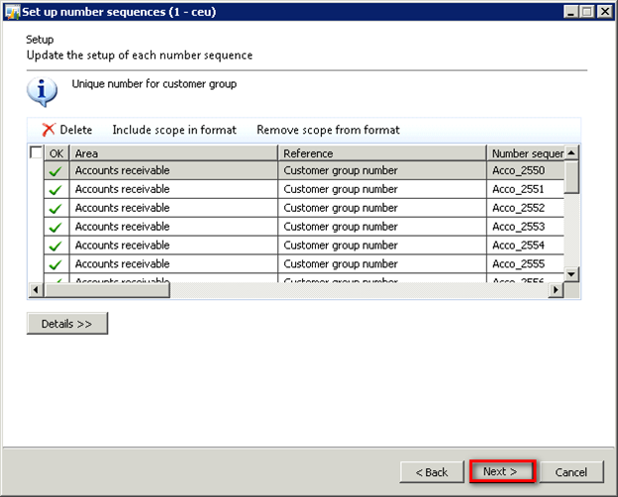
6. In the last step, Click **Finish** to generate the number sequences
   1. 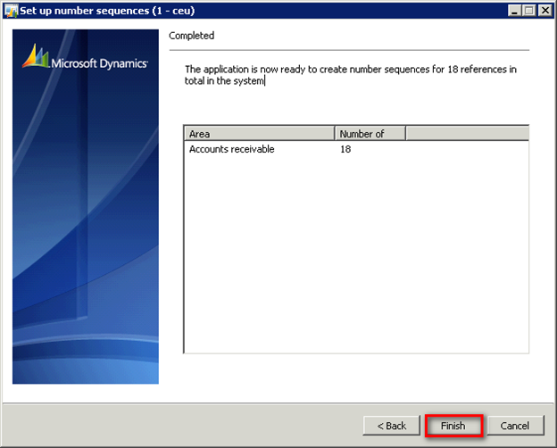
7. The number sequence is generated and can be used on the Customer Groups form
8. Open **AOT → Data Dictionary → Tables → NumberOfSequenceTable**
9. Add a new **String** field and set the properties as follows
   1. 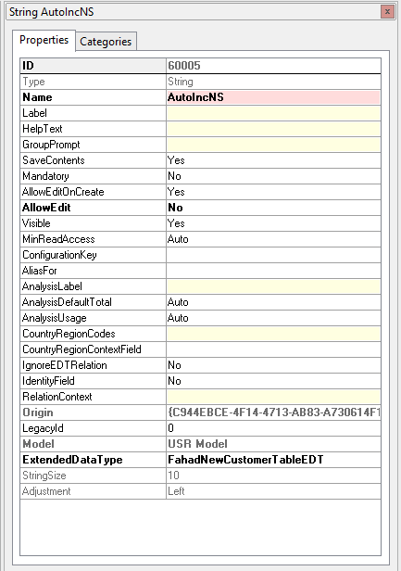
10. Add the newly added field in the Overview field group
    1. 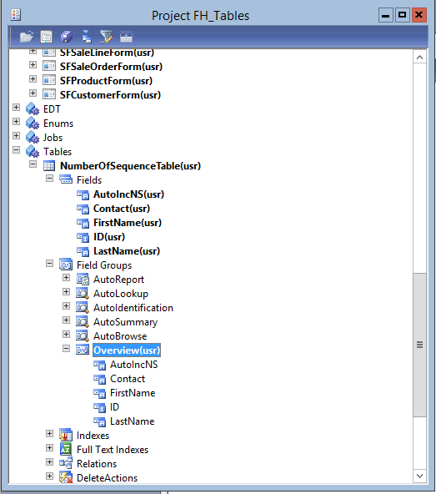
11. Now go to **Forms →FahadFormNumberSequence** and restore the form. It will add the newly added field in the grid
    1. 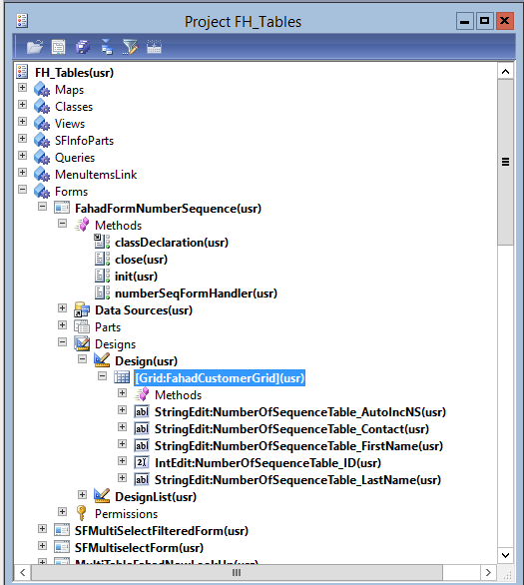
12. Write the following code on the Class declaration node
13. Create a new method on the form and write the following code
14. Make this Fucntion in foam

|  |
| --- |
| 1. Create object in class decelation of foam   NumberSeqFormHandler numberSeqFormHandler;  NumberSeqFormHandler numberSeqFormHandler()  {  **if** (!numberSeqFormHandler)  {  *//create a reference of number sequence form handler class specifying the EDT, Data source name and the field of the table*  numberSeqFormHandler =NumberSeqFormHandler::newForm(NumberSeqReference::findReference(**extendedtypenum**(FahadNewCustomerTableEDT)).NumberSequenceId, element,NumberOfSequenceTable_DS,**fieldnum**(NumberOfSequenceTable,AutoIncNS));   * 1. }   2. **return** numberSeqFormHandler;   3. } |
|  |

1. Override the **close** method of the form and write the following code

|  |
| --- |
| **public void** close() { **if** (numberSeqFormHandler) { numberSeqFormHandler.formMethodClose(); }  **super**(); } |

1. Make Init Function in the function foam and add code

|  |
| --- |
| **public** **void** init()  {  **super**();  **if** (RetailSMB::IsRetailSMBEnabled())  {  RetailSMB::SetVisible(element);  }  } |

1. Override the **create** method on the  **data source you added on foam** and add the following code

|  |
| --- |
| **public void** create(**boolean** _append = **false**) { element.numberSeqFormHandler().formMethodDataSourceCreatePre();  **super**(_append);  element.numberSeqFormHandler().formMethodDataSourceCreate(**true**); } |

1. Override the **write** method on the **NumberOfSequenceTable** data source and add the following code

|  |
| --- |
| **public void** write() { **super**();  element.numberSeqFormHandler().formMethodDataSourceWrite(); } |

1. Override the **validateWrite** method on the **NumberOfSequenceTable** data source and add the following code

|  |
| --- |
| **public boolean** validateWrite() { **boolean** ret;  ret = **super**();  ret = element.numberSeqFormHandler().formMethodDataSourceValidateWrite(ret) && ret;  **return** ret; } |

1. Override the **delete** method on the **NumberOfSequenceTable** data source and add the following code

|  |
| --- |
| **public** **void** delete() {  element.numberSeqFormHandler().formMethodDataSourceDelete();  **super**(); } |

1. Override the **linkActive** method on the **NumberOfSequenceTable** data source and add the following code

|  |
| --- |
| **public** **void** linkActive() {  element.numberSeqFormHandler().formMethodDataSourceLinkActive();  **super**(); } |

1. Now go to **AOT → Forms → FahadFormNumberSequence**
2. Create a new record. The number sequence is generated according to the format defined as shown below
   1. 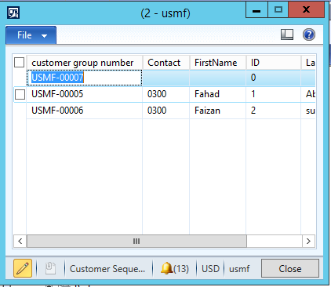
   2. **Problem: If you add data and close the form and according to you the data must be saved but when you open the form the again the number sequence field show “unretreived”**
   3. **Solution: Restart you AOS all the values that you have in which you think the number sequence value must remain saved automatically become visible after restarting you AOS and after this time whenever you save your data it will never show “unretreived”**

**1.**

**C:\Users\Sohaib\Downloads\1 (1).PNG**

**2.**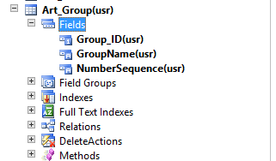

**3.  
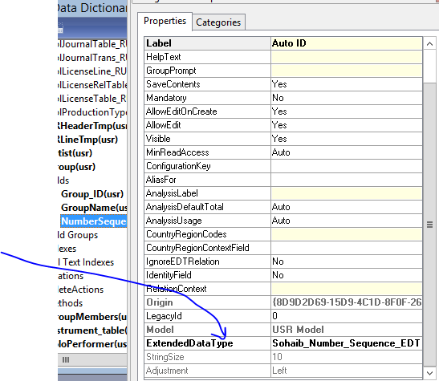**

**4.** 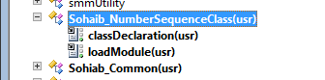

**5.**

**.**